AUGUST 2025
Subject: The Power of Preventive Care



BE PROACTIVE ABOUT PREVENTIVE CARE
Preventive care is essential for maintaining long-term health. With summer winding down and school yet to start in many locations, it’s a great time to schedule preventive medical, dental and vision appointments for you and your family members.
Why Preventive Care is Important  Preventive care is all about taking simple steps now to help you stay well later, by catching issues early or stopping them before they start. The best part? Most in-network preventive services are covered 100% by your health plan, so staying on top of your health doesn’t have to cost you a thing.  Here are some examples of preventive care services:  - Your annual check-up  - Cancer screenings  - Childhood/Adult immunizations  - Your annual flu shot  Visit uhc.com to learn about the different parts of preventive care and how they play a role in keeping you healthy. |   Did you know…  In 2023, La Roche-Posay skincare brand set a Guinness World Record by completing 1,988 skin cancer screenings in just 8 hours during a pop-up event in New York City. It was part of their “Save Our Skin” campaign to raise awareness about early detection and sun safety.

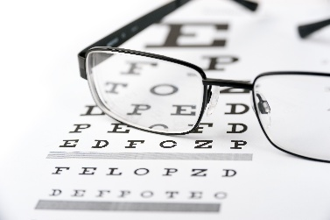  Keep an “Eye” on Your Vision  People spend an average of 7 hours and 3 minutes per day looking at computer and phone screens! Try these ideas to help protect and rest your eyes throughout the day:  - Blink often: Blinking keeps eyes lubricated and transfers oxygen to the cornea. Actively blink when you open an email or are waiting for a page to load.  - 20-20-20 Rule: Every 20 minutes, look at something 20 feet away for 20 seconds. This forces your eyes to move from short to long distance perception, giving them a rest.  - Modify your workstation: Sit at least an arm’s length away from the screen and make sure the center of your screen is four to five inches below eye level.  Visit eyemed.com or call 866-800-5457 to find a vision provider |  | 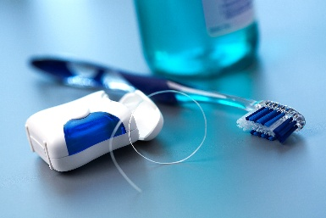  “Check up” on Your Dental Benefits  Did you know...The average American spends 38.5 days of their life brushing their teeth! Numerous studies show a link between regular dental cleanings and disease prevention. Here are some tips to maximize your dental plan:  - Regular Check-ups: Schedule check-ups every six months to prevent issues.  - Understand Your Plan: Know what your plan covers, including cleanings, x-rays, fillings, and orthodontia.  - Plan for Major Work: Coordinate with your dentist to understand coverage and out-of-pocket costs.  - Use Your FSA: Utilize your Flexible Spending Account for expenses not covered by your plan.  To find an in-network provider, visit DeltaDentalmi.com or call 800-524-0149.
Want More Details About Your TG Benefits?
Visit our benefits website, tggroupbenefits.com (password: TGNA; location: United States).
There, you’ll find helpful information about all your benefits.

